1. Navigate to data folder in left pane (*Current Folder* window) of MATLAB and double-click on the file to load it in. (If you can’t find the *Current Folder* window or other windows I refer to you can make them show up by clicking on “Layout” in the top menu (under the **Home** tab) and checking the box for them, see below).

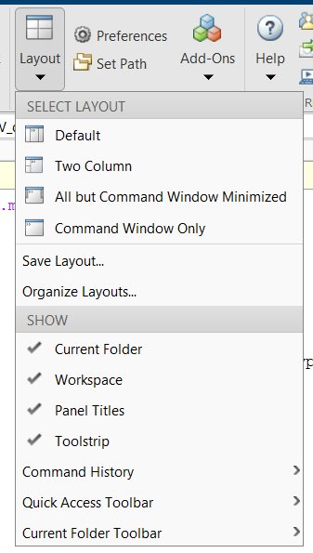

1. This should load in the “Calls” variable to your *Workspace* (top right window).

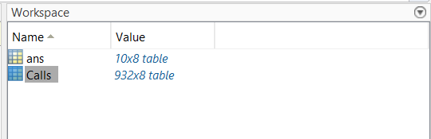

1. Now look at the data! We don’t want to see all the rows at once, so you can view it two ways.
   1. You can type >> **Calls(1:10, :)** into the *Command Window* at the bottom. This will show only rows 1-10. If you wanted to show only the first 20 rows and only columns 2-5, you would type >> **Calls(1:20, 2:5)** and so on (see below, and note that you might have to scroll right to see all the values depending on your monitor/font size), OR

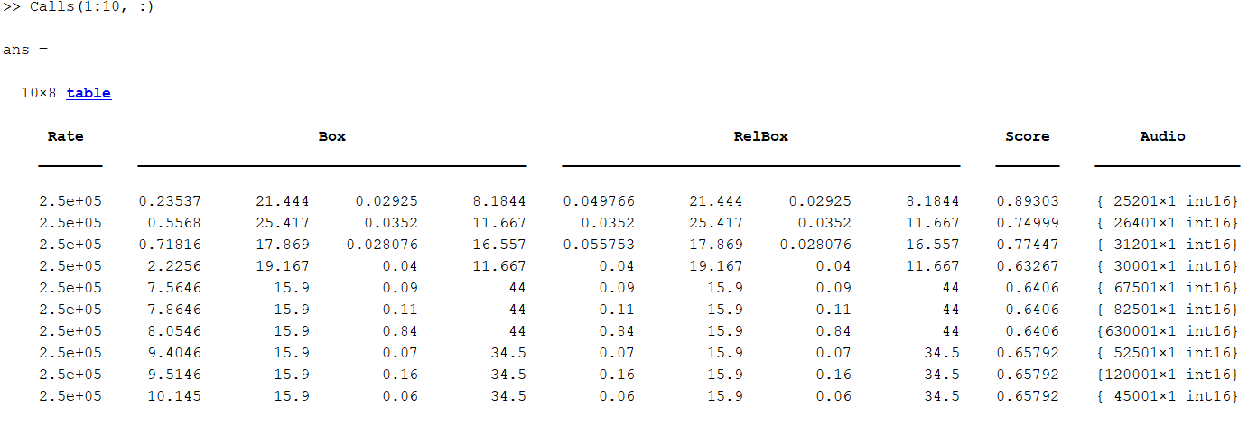

* 1. You can double click on **Calls** in the *Workspace*. This will open up a new *Variables* window in the top/middle where you can scroll through and view the data easily and even change it. Notice what happens in the *Command Window* when you change a value. This will give you hints how you might be able to manipulate these variables directly in the *Command Window*.

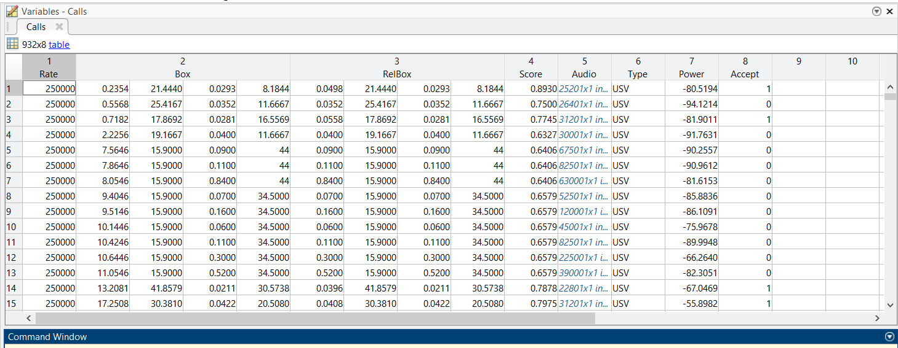

1. What we really want is grab out the times and frequency ranges of each call. To do that I’m writing a few function calls **extract_calls** for you to grab things which are posted at: <https://github.com/diba-lab/ephys/tree/master/behavior/Analysis>.
2. Once you’ve got that data, you’ll need to run another function to separate high from low calls. This call is named **separate_calls**. Remember that for both calls you can look at their documentation by typing >> **help** followed by the function name. If you want to look at the function itself, you can either open it from the top (“Open” button), right click on the function in the *Current Folder* and select Open, or (easiest) type **edit** followed by the function name.
3. Last, you’ll need to plot the results! Here is some code to plot things that might be useful:
   1. **>> [times, mean_freq] = extract_calls(Calls)**
   2. **>> [calls_sep, high_bool] = separate_calls(times, mean_freq).**
   3. **>> figure; histogram(mean_freq)**
   4. **>> figure; boxplot(mean_freq)**
   5. 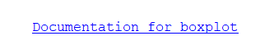**>> figure; boxplot(mean_freq, high_bool)** – what does this do? Try digging through my code to figure out what the high_bool variable is and typing **help boxplot** to figure out how that function works. You can also access more info about boxplot (or any function) by scrolling to the bottom of the text that pops up when you type **help** and clicking on